Diss and District Neighbourhood Plan

Non-Designated Heritage Assets Working Group – Starter Pack

March 2020

Introduction

Heritage assets are either designated or non-designated. Designated assets include listed buildings, scheduled monuments, protected wreck sites, historic parks and gardens, battlefields, World Heritage Sites and Conservation Areas. Listed buildings are designated because of their special architectural or historic interest. Most heritage site are buildings or structures, but whatever they are they need to relate to human history.

Non-designated heritage assets are buildings, monuments, etc identified by plan-making bodies as having a degree of heritage significance meriting consideration in planning decisions, but which do not meet the criteria for designated heritage assets. Only a minority of buildings will have enough heritage significance to merit identification as non-designated heritage assets. It’s important that there is sound evidence and justification for why they are important to the community, what sets them out from other buildings.

The first sections of this report show the heritage assets that are already designated and that therefore do not need any attention, apart from the need to avoid including them in the work.

The final section is the advice provided in the National Planning Practice Guidance on non-designated heritage assets.

Designated Assets within the NP area

Overall distribution of listed buildings across the NP area:
Parish | Listed Buildings | Scheduled Monuments
Brome and Oakley | 40: 4 Grade II*
Burston and Shimpling | 26: 1 Grade I,
Diss | 157: 1 Grade I, 2 Grade II*
Palgrave | 41: 1 Grade I, 1 Grade II*
Roydon | 31: 1 Grade I
Scole | 50: 3 Grade I, 4 Grade II* | 1: Scole Roman Settlement
Stuston | 17: 1 Grade II*
Total | 356

Brome and Oakley
Total number of listed buildings: 40
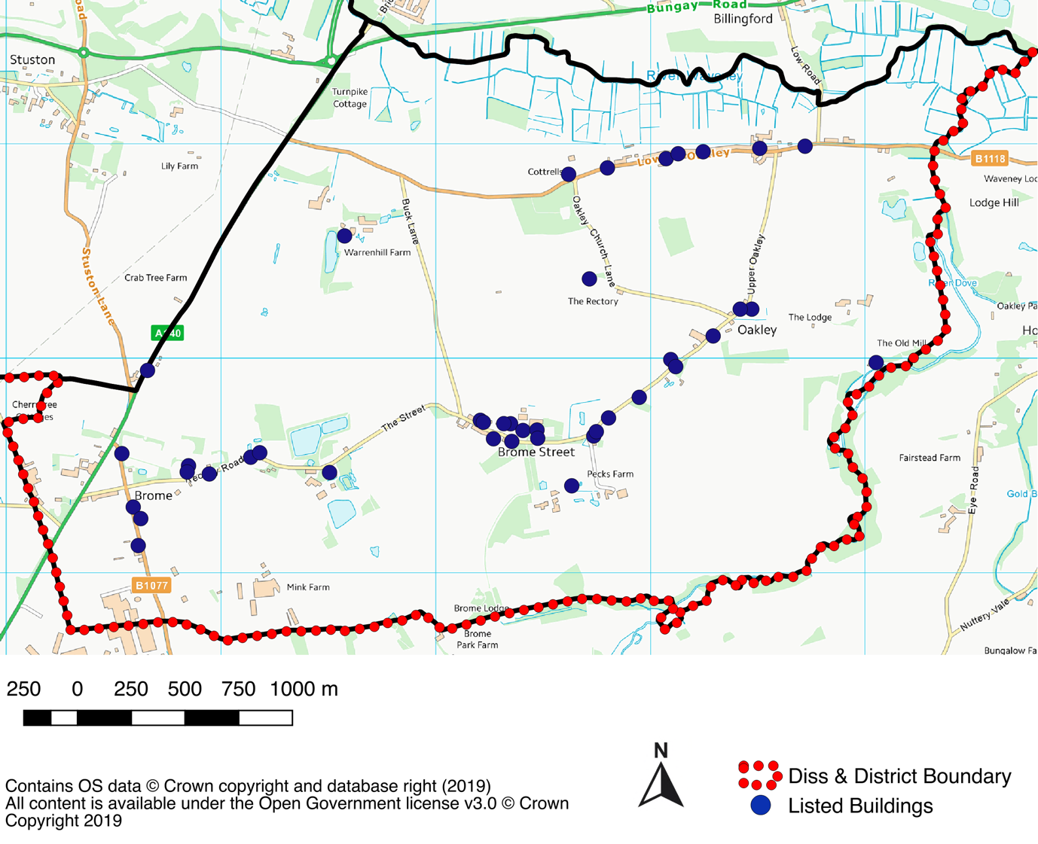
Including the following, with names as per the listing register:
- 1 And 2, The Street  - 30 And 32, Eye Road  - "Amara Tam And Brome Villa"  - Batrums  - Byways  - Church Of St Mary (Grade II*)  - Church Of St Nicholas (Grade II*)  - Cornwallis Cottages  - Cottrell's  - Dunt Cottage  - Entrance Gates 300 Metres West North West Of Oaksmere  - Garden House 30 Metres South Of Ivy House  - Heale Cottage  - Ivy House  - Kitchen Garden Walls Immediately North East Of Oaksmere (Including Vehicular Entrance)  - Little Thatch  - Mill House  - Number 11 Upper Oakley | - Number 42 Lower Oakley  - Numbers 17 And 19 Upper Oakley  - Oak Cottage  - Oak Tree Cottage  - Oakley House  - Oaksmere  - Park Farmhouse (Grade II*)  - Poplar Farmhouse (Grade II*)  - Ripley Cottage  - Rose Cottage  - Stone Cottage  - Tanglewood  - The Bungalow  - The Green Man  - The Homestead  - The Homestead  - The Magnolias  - The Old Curacy  - The Old Mill  - The Old Post Office  - Warren Hill Farmhouse  - Weaver's Cottage
All entries are Grade II unless otherwise identified as such.

Burston and Shimpling
Total number of listed buildings: 26
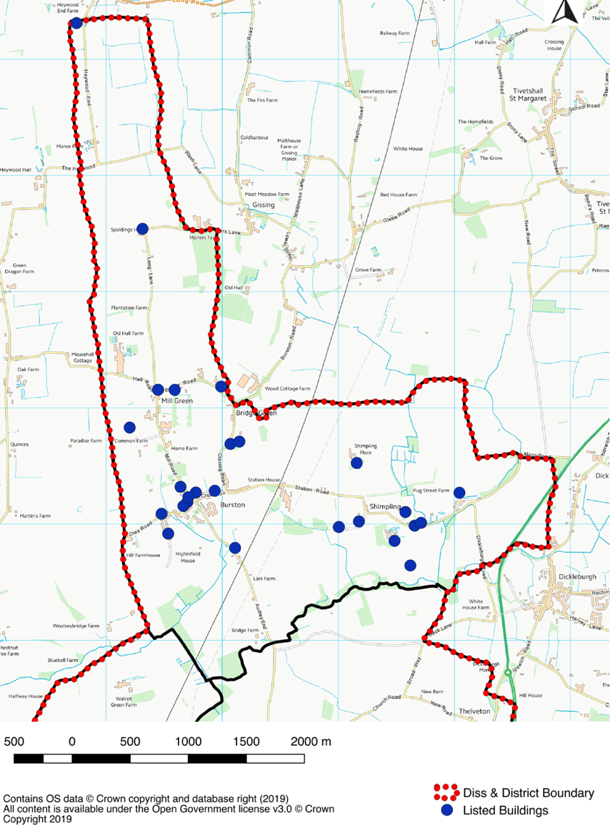
- 121, Gissing Road  - 2, 3 And 4, Dickleburgh Road  - 43, Long Lane  - Bridge Green Farmhouse  - Church Of St George  - Church Of St Mary  - Crown Farmhouse  - Culpher Farmhouse  - Far End  - Grove Cottage  - High House Farmhouse  - Low Farmhouse  - Manor House Farmhouse  - Market Farmhouse | - Mrs Seal's Cottage Pair Of Cottages Occupied By Mrs Cattermole And Mr Rudd Approximately 150 Yds West Of Culper Farmhouse  - Pear Tree Cottage  - Rectory Cottage  - Red House  - Shimpling Hall  - Shimpling Place  - The Crown Public House  - The Strike School  - Valley Farmhouse  - Valley Farmhouse  - Ye Olde Cottage
Diss
Total number of listed buildings: 157
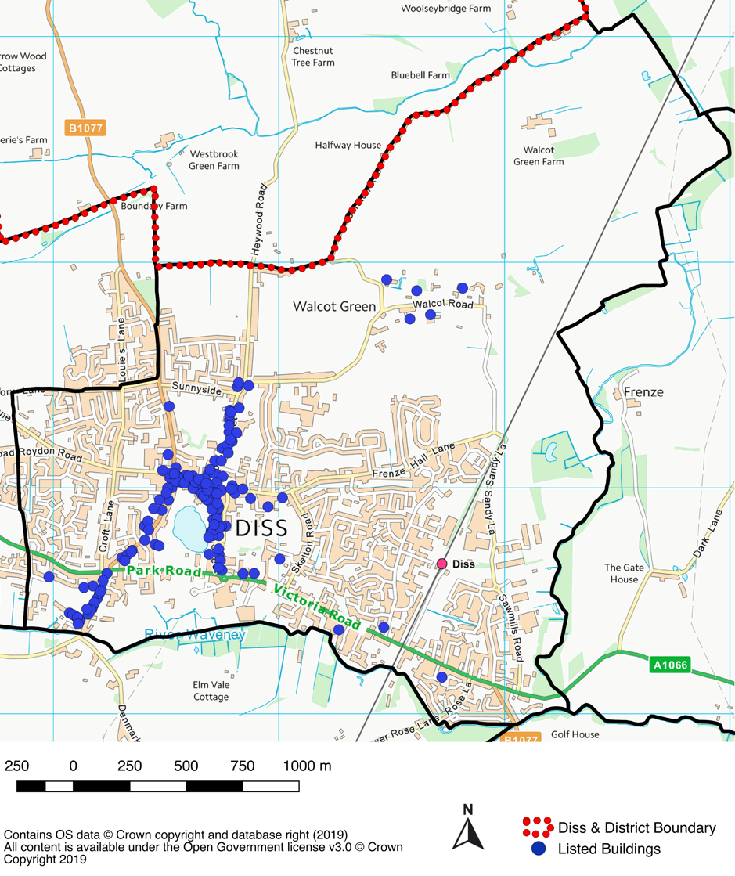

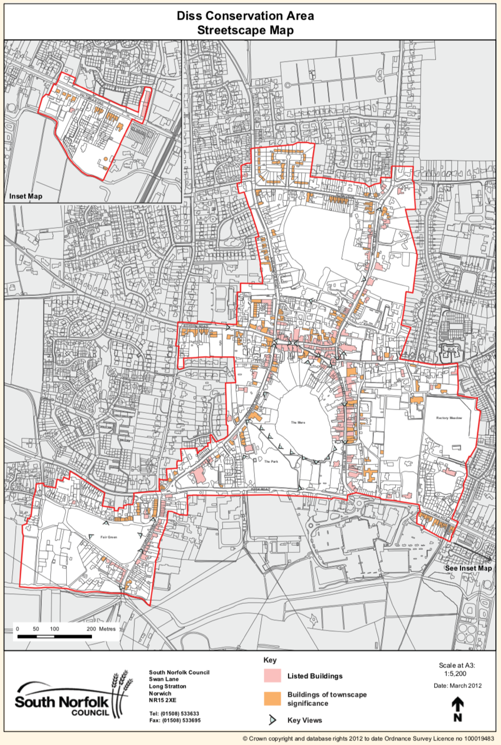

Listed Buildings  - 1 & 2, Roydon Road  - 1 & 2, Shelfanger Road  - 1-3, Market Place  - 1, Church Street  - 1, Mere Street  - 10-13, Mount Street  - 10, Market Place  - 100-102, Denmark Street  - 103, Denmark Street  - 11 & 12, Mere Street  - 12 & 12a, St Nicholas Street  - 13-15, Mere Street  - 13, Market Hill  - 13, St Nicholas Street  - 14, 14a, & 14b, St Nicholas Street  - 14, 15 & 15a, Market Place  - 14 & 15, Market Hill  - 14 18 18a 19, Mount Street  - 16 16a, Market Place  - 17 17a 18, Market Place  - 17 18, St Nicholas Street  - 18, Church Street  - 18, Mere Street  - 19 20, St Nicholas Street  - 19, Denmark Street  - 1a 1b 1c, Market Hill  - 2 2a, Fair Green  - 2 3, Mere Street  - 2 And 3, Church Street  - 2, Market Hill  - 2, Mount Street (Grade II*)  - 2, St Nicholas Street  - 2, Victoria Road  - 21, Fair Green  - 21, St Nicholas Street  - 23 23a, St Nicholas Street  - 23 24, Denmark Street  - 23 24, Mount Street  - 24, St Nicholas Street  - 24a 25, St Nicholas Street  - 25-27, Mere Street  - 25, Denmark Street  - 26-28, Denmark Street  - 26, Mount Street  - 26, St Nicholas Street  - 27, St Nicholas Street  - 28 29, Fair Green  - 28, St Nicholas Street  - 29, Mount Street  - 29, St Nicholas Street  - 3-5, Denmark Street  - 3, Mount Street  - 3, St Nicholas Street  - 30 31, Fair Green  - 30-33, Mount Street  - 33-35, Mere Street  - 34, Mount Street  - 35-37, Chapel Street  - 35, Mount Street  - 36 36a 36b, Mere Street  - 37-45, Denmark Street  - 38, Chapel Street  - 4 5, Market Place  - 4-6, Market Hill  - 4, Fair Green  - 4, St Nicholas Street  - 41, Mere Street  - 42, Mere Street  - 44 45, Mere Street  - 46 47, Mere Street  - 47-49, Denmark Street  - 48 50, Mere Street  - 49 50, Mount Street  - 5, St Nicholas Street  - 5, Victoria Road  - 6, Mere Street  - 6, Victoria Road  - 60 61, Denmark Street  - 60, Mount Street | - 50, Denmark Street  - 51 52, Denmark Street  - 51 54, Mere Street  - 52, Shelfanger Road  - 53 54, Denmark Street  - 55 56, Denmark Street  - 57 58, Denmark Street  - 6 6a, St Nicholas Street  - 6 And 7, The Entry  - 62 63, Denmark Street  - 62, Mount Street  - 64 Mount Street  - 65-67, Denmark Street  - 68 69, Mount Street  - 7 8, Mere Street  - 7-9, Denmark Street  - 7, Church Street  - 7, St Nicholas Street  - 8 9, Market Hill  - 8, Market Place  - 8, St Nicholas Street  - 82 83, Denmark Street  - 84-86, Denmark Street  - 9, Market Place  - 9, St Nicholas Street  - 98, Victoria Road  - Alger's Farmhouse  - Brewery House  - Church Of St Mary (Grade I)  - Churchyard Walls Of St Marys Church  - Cock Green Cottage  - Coffee Tavern  - Congregational Church  - Corn Hall  - Denmark Street Hall  - Dolphin Cottage  - Dolphin House (Grade II*)  - Eaton Lodge  - Entrance Piers Of Linden House  - Entrance Wall & Piers Of Number 60  - Fair Green House  - Franwin  - Friends Meeting House  - Front Walls At Flanks Of No 29  - Garden Wall At Number 60  - Hatters  - Heywood Cottage  - Home Farmhouse  - Homestead  - Houghton House  - K6 Telephone Kiosk  - K6 Telephone Kiosk  - Kings Head Hotel  - Linden House  - Maltings  - Maltings  - Masonic Hall  - Mere Manor  - Oak Lodge  - Old Maltings  - Park Hotel  - Park House  - Pine House  - Railings Of Enclosure Of No 18a  - Saracens Head Inn  - Summerley  - Sun Inn  - Thatch (Cottage)  - The Denmark Arms Inn  - The Grove  - The Manor House  - The Two Brewers Inn  - Urban District Council Offices  - Wall, East Of Saracens Head Inn  - Walls And Gate Piers At Front Boundary At Oak Lodge  - West Boundary Walls Of No 1  - White Horse Inn  - Wilderness Cottage

Palgrave
Total number of listed buildings: 41
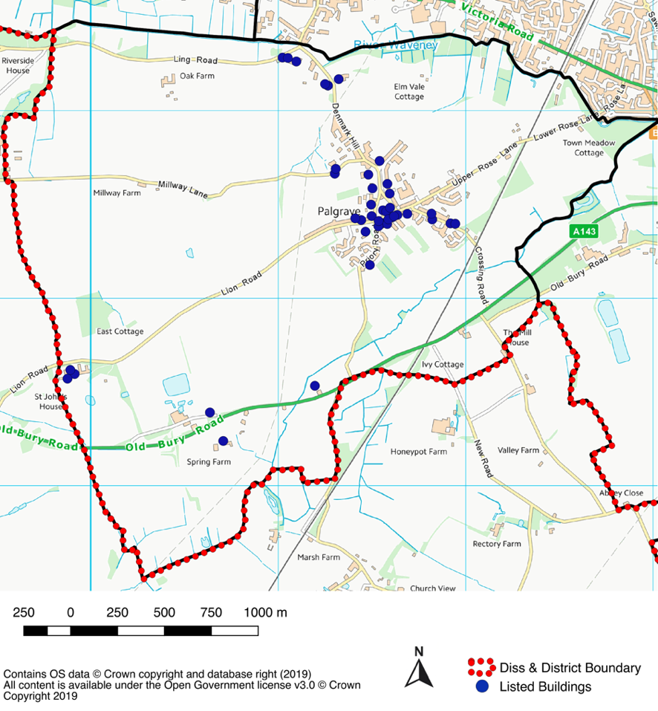
- Barn About 35m West Of Spring Farm House  - Brackendale (Grade II*)  - Bridge Farm Cottages  - Bridge Farm House  - Burlington Cottages  - Catchpole Memorial About 15m South Of Church Of St Peter  - Church Farm House  - Church Of St. Peter (Grade I)  - Clarks Yard  - Denmark Bridge House  - Elm Vale Farm House  - Fairways  - Forge Cottage And Harrow Cottage  - Former Grooms House And Coach House About 30m East Of Park House  - Former Stable Block At St Johns Farm About 15m North Of Park House  - Garnet House  - Hemplands With Attached Outbuildings  - Ivy Cottage  - Ivy House  - K6 Telephone Kiosk | - Lime Tree Farm House  - Longs Farm House  - North View  - Orme House  - Park House  - Peanut Cottage And Hill Cottage  - Penning Memorial About 30m East Of Church Of St Peter  - Post Office And Stores  - Priory Farm Cottages  - Sun View Cottage  - Sunnyside Cottage  - The Cottage  - The Cottage Near Church  - The Hollies  - The Paddocks And Paddocks Side  - The Priory  - The Swan  - The Thatches  - Valley Farm House  - Weavers Mark  - Wood Cottage

Roydon
Total number of listed buildings: 31
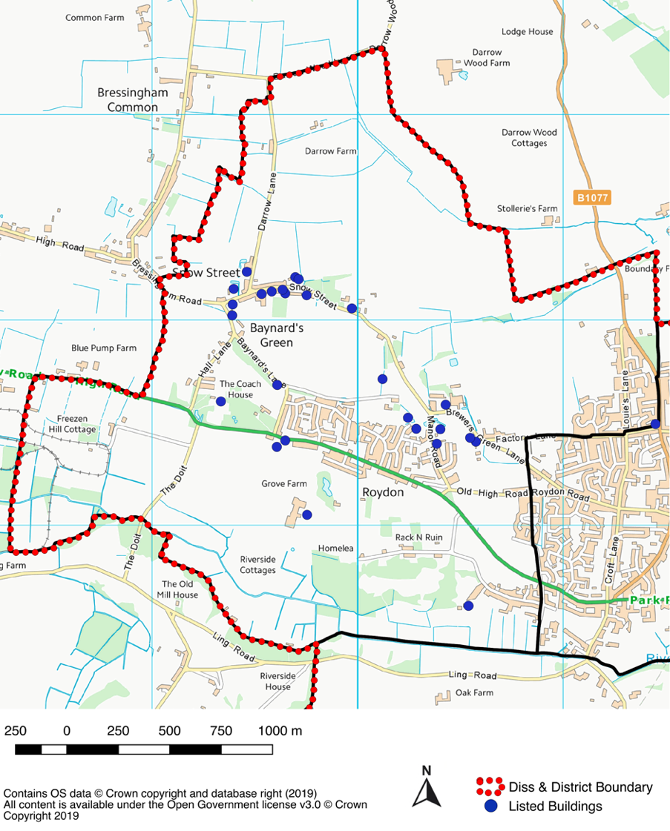
- 1a And 1b, Shelfanger Road  - 20 And 21, Snow Street  - 22 And 23, Snow Street  - Bethany  - By The Potash  - Church Of St Remigius (grade I)  - Firtree Farmhouse  - Glebe Farmhouse  - Gringle Cottage  - Grove Farmhouse  - Limetree Farmhouse  - "Little Manor  - Middle Manor  - The Manor House"  - "Manor Cottage  - The Cottage" | - Manor Farmhouse  - North House  - Rose Villa  - Roydon Hall  - Roydon War Memorial  - Snow Cottage  - "Thatch End  - “The Haven"  - The Friary And Adjoining Outbuilding To West  - The Gables  - The Hermitage  - The Old Post Office  - The Pheasantry  - The Poplars  - White House Farmhouse

Scole
Total number of listed buildings: 50
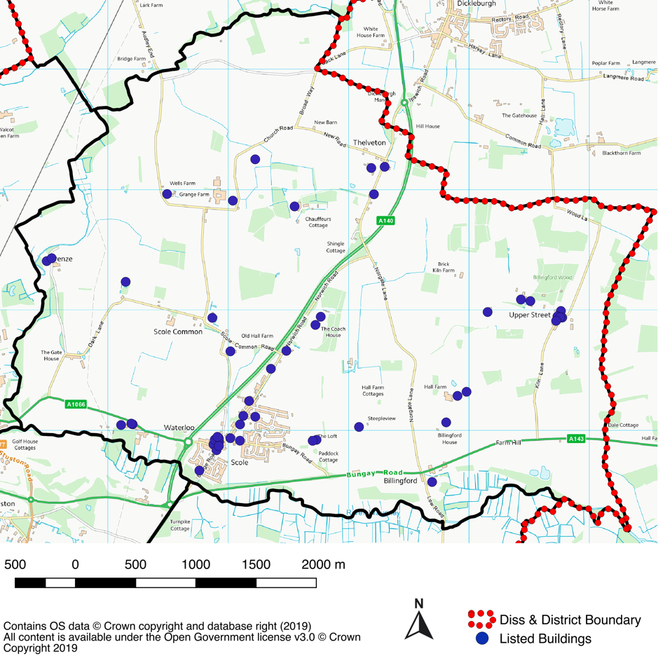

- 5, Diss Road  - Barn Immediately North-West Of Street Farmhouse  - "Beam Ends  - Gable End  - Three Ways"  - Billingford Hall  - Billingford Windmill (Grade II*)  - Bottle Cottages  - Calvers Farmhouse  - Church Of St Andrew (Grade II*)  - Church Of St Andrew Thelveton (Grade II*)  - Church Of St Andrew, Frenze (Grade I)  - Church Of St Leonard, Billingford (Grade I)  - Coach House And Stable At Manor  - Farm  - Common Farmhouse  - Corner Cottage  - Crossways Restraurant  - Dovecote Approximately 80 Yds North-East Of Billingford Hall  - Frenze Hall  - Frenze House  - Grove Farm Cottages  - High House  - House Occupied By Mr And Mrs Thurlow  - Kitchen Garden Wall Adjoining North-East Of The Paddocks | - Lodge Farmhouse  - Mill Building Immediately North Of Mill House  - Old Beams  - Old Hall Farmhouse  - Orchard Cottage  - Orchard Cottage  - Remains Of Church Of St Mary, Thorpe Parva  - Scole Inn (Grade I)  - Scole Lodge Nursing Home  - Scole War Memorial  - Shingle House  - St Edmunds Lodge  - Stables Immediately North-West Of Scole Inn  - Stables North Of Scole Lodge Nursing Home  - Street Farmhouse  - Thatched Cottage  - Thatchet  - The Grange  - The Moat House  - The Paddocks  - The White House  - Thelveton Hall (Grade II*)  - Unicorn Cottage  - Wells Farmhouse  - Willow House

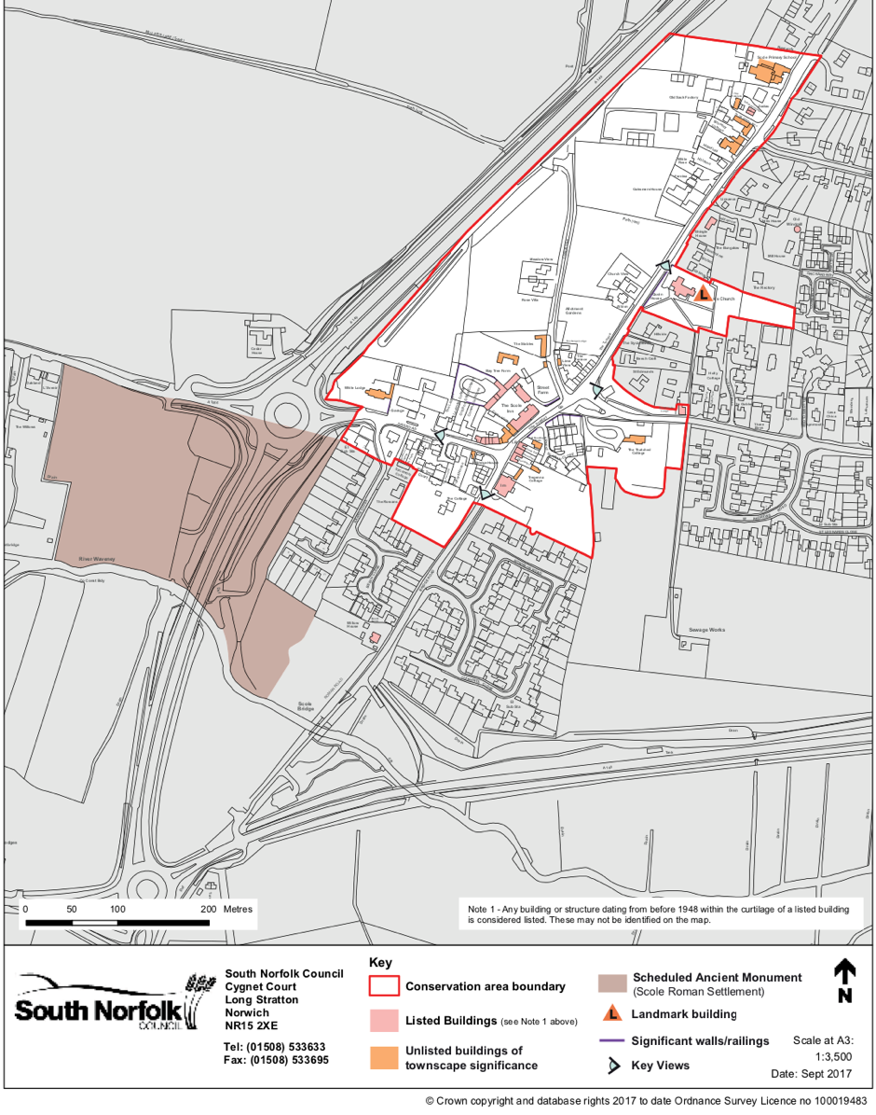
Stuston
Total number of listed buildings: 17
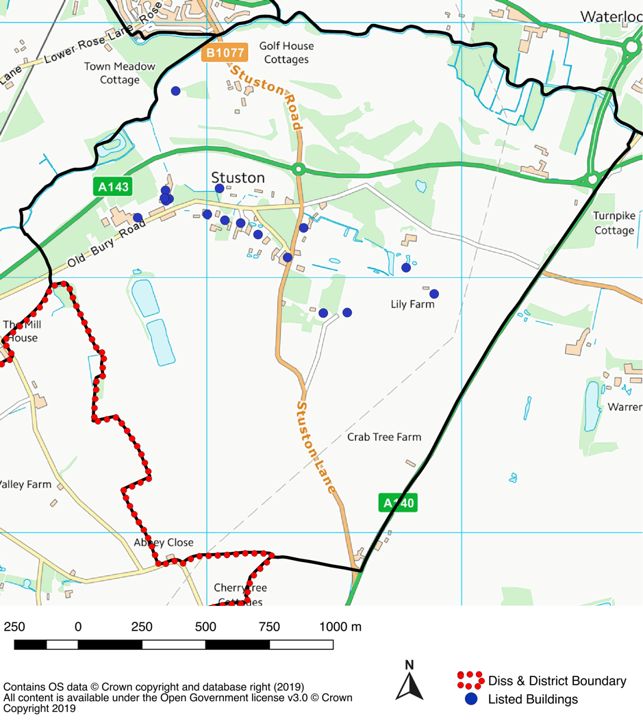
- Cardrews  - Church Cottage  - Church Of All Saints (Grade II*)  - Endon House  - Hall Farm Cottage  - Hauntons Farm House  - Lily Farm House  - Old Swan House  - Rosemary Farm House | - Stuston Lodge  - Stuston Place Farm House  - Talbot Cottage  - The Bungalow  - The Nuthatch  - Town Meadow Cottage  - Tyrells Farm House  - Willow Farm House

Non-designated heritage assets

What are non-designated heritage assets?
Non-designated heritage assets are buildings, monuments, sites, places, areas or landscapes identified by plan-making bodies as having a degree of heritage significance meriting consideration in planning decisions but which do not meet the criteria for designated heritage assets.
A substantial majority of buildings have little or no heritage significance and thus do not constitute heritage assets. Only a minority have enough heritage significance to merit identification as non-designated heritage assets.

How are non-designated heritage assets identified?
There are a number of processes through which non-designated heritage assets may be identified, including the local and neighbourhood plan-making processes and conservation area appraisals and reviews. Irrespective of how they are identified, it is important that the decisions to identify them as non-designated heritage assets are based on sound evidence.
Plan-making bodies should make clear and up to date information on non-designated heritage assets accessible to the public to provide greater clarity and certainty for developers and decision-makers. This includes information on the criteria used to select non-designated heritage assets and information about the location of existing assets.
It is important that all non-designated heritage assets are clearly identified as such. In this context, it can be helpful if local planning authorities keep a local list of non-designated heritage assets, incorporating any such assets which are identified by neighbourhood planning bodies. (Advice on local lists can be found on Historic England’s website.) They should also ensure that up to date information about non-designated heritage assets is included in the local historic environment record.
In some cases, local planning authorities may also identify non-designated heritage assets as part of the decision-making process on planning applications, for example, following archaeological investigations. It is helpful if plans note areas with potential for the discovery of non-designated heritage assets with archaeological interest. The historic environment record will be a useful indicator of archaeological potential in the area.

What are non-designated heritage assets of archaeological interest and how important are they?
The National Planning Policy Framework identifies two categories of non-designated heritage assets of archaeological interest:
(1) Those that are demonstrably of equivalent significance to scheduled monuments and are therefore considered subject to the same policies as those for designated heritage assets (National Planning Policy Framework footnote 63). They are of 3 types:
- those that have yet to be formally assessed for designation.
- those that have been assessed as being nationally important and therefore, capable of designation, but which the Secretary of State for Digital, Culture, Media and Sport has exercised his/her discretion not to designate.
- those that are incapable of being designated by virtue of being outside the scope of the Ancient Monuments and Archaeological Areas Act 1979 because of their physical nature.

The reason why many nationally important monuments are not scheduled is set out in the document Scheduled Monuments, published by the Department for Digital, Culture, Media and Sport. Information on location and significance of such assets is found in the same way as for all heritage assets. Judging whether sites fall into this category may be assisted by reference to the criteria for scheduling monuments. Further information on scheduled monuments can be found on the Department for Digital, Culture, Media and Sport’s website.
(2) Other non-designated heritage assets of archaeological interest. By comparison this is a much larger category of lesser heritage significance, although still subject to the conservation objective. On occasion the understanding of a site may change following assessment and evaluation prior to a planning decision and move it from this category to the first.
Where an asset is thought to have archaeological interest, the potential knowledge which may be unlocked by investigation may be harmed even by minor disturbance, because the context in which archaeological evidence is found is crucial to furthering understanding.
Decision-making regarding such assets requires a proportionate response by local planning authorities. Where an initial assessment indicates that the site on which development is proposed includes or has potential to include heritage assets with archaeological interest, applicants should be required to submit an appropriate desk-based assessment and, where necessary, a field evaluation. However, it is estimated that following the initial assessment of archaeological interest only a small proportion – around 3% – of all planning applications justify a requirement for detailed assessment.

